**Practical 06: Working with Java Script**

**Section A:**

**Lab Exercise (Compulsory)**

**Question 1**

1. Create an external javascript file named “***general.js***” that contain the following declaration:
2. Create a **init()** that will be executed when the form is loaded :

* Display the current date into the *Order Date* field with id “date”.
* Set focus in *Customer Name* field with id “customerName.

1. Use the following to call the function if the Submit Order button is clicked

document.forms[0].onsubmit = function() {}

1. Create the followings for the function() {}

* Ensure the Order form customer name and Tel No is complete by using “this.checkValidity()”.
* If the totalAmount is greater than 0, then
* Display a confirm dialog box (*figure 2*) to ask the user “Are you sure you would like to submit the book order?”
* If user clicks on OK button, then
  + Submit the data .
  + Display alert dialog box (*figure 3*).
  + Print the order data.
* If user clicks on Cancel button, remain to the same page.
* If the totalAmount is not greater than 0, then
  + Display alert dialog box with the message "Total Amount is invalid".
  + Return to false value.

1. Open ***Book_select_txt.html*** as shown in *figure 1.* Save as filename***Book_select.html.*** Create the JavaScript functions in the following in “Book.html”:
2. Insert a statement in <head> section to access to the external JavaScript file created in part (a).
3. Create a **display(obj,num)** function that will be executed when the book selection list (e.g. id “desc1”) is changed:

* Create the following variables to store different data.

var price = "Price" + num;

var qty = "Quantity" + num;

var amount = "Amount" + num;

* if the selected index is not equal to zero (0), then ,
  + Then display the book price in the respective text box (e.g. id “price1”).
  + Set the value of qty and amount to “0” and “0.00”.
  + Make the respective quantity selection list (e.g. id “quantity1”) to be enabled and set focus on to the object.
  + Call calculate function.

1. Create a **sub(obj,num)** function that will be executed when the quantity selection list (e.g. id “quantity1”) is changed:

* Create the following variables to store different data.

var amount = "Amount" + num;

var price = "Price" + num;

var qty = obj.selectedIndex;

* If the qty is greater than zero , then
  + Calculate the Amount of the book purchased by multiplying the book object’s price and the quantity selected.
  + Display the Amount in the respective text box (e.g. id “Amount1”) .
* Else set the Amount to “0.00” , and call calculate function.

1. Create a **calculate()** function that will be executed when when the quantity selection list (e.g. id “quantity1”) is changed:

* Create the following variables.

var amt1, amt2, amt3, total;

* Calculate the Total Amount by adding the values displayed in all the Amount text boxes.
* Display the Total Amount in the text box with id “totalAmount”.

1. Write an **onclick** event handler for *Cancel Order* button to display a confirm dialog box (*figure 4*) to ask user “Are you sure you want to cancel this order?”.

* If user clicks on Ok button, close the window, else reload the form page.

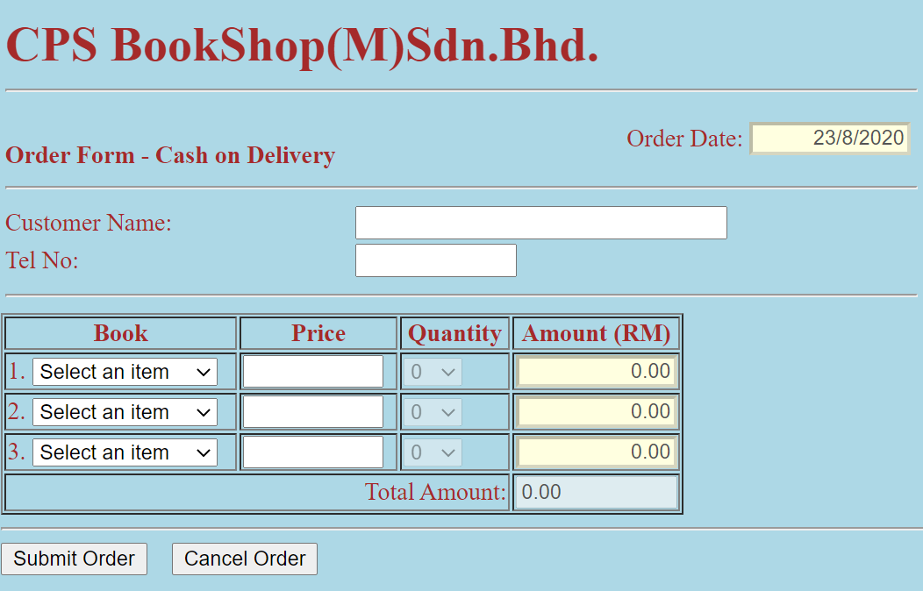

**Figure 1**

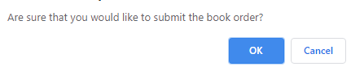

**Figure 2**

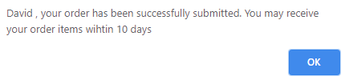

**Figure 3**

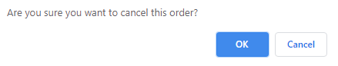

**Figure 4**

**Question 2**

* Design a screen as shown in *Figure 1.*
* Set the New Year date on “January 1, 2021”.
* Display current date and the number of days left until New Year in ***DayCount.htm***.

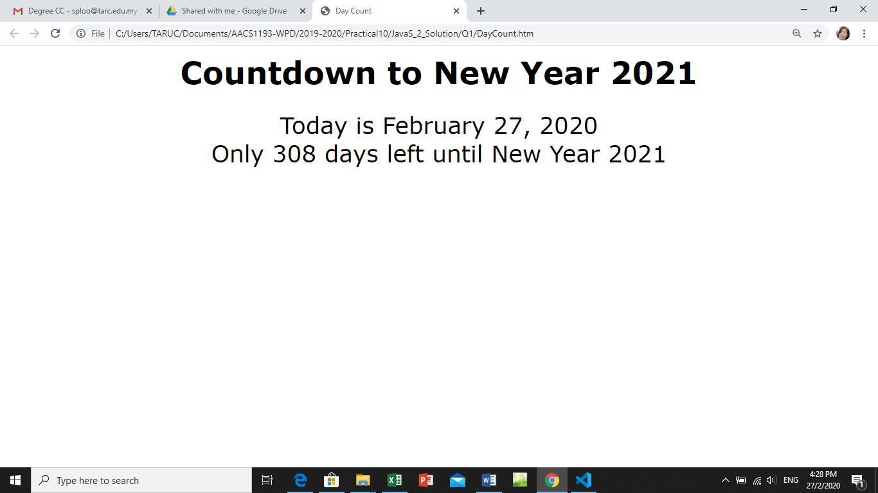

**Figure 5**

**Additional Question**

**Question 1**

The mortgage finance officers at Frontier Savings and Loan have asked you to create a mortgage calculator that customers can use to estimate monthly mortgage payments. Your web page should contain a form in which the customer enters the loan amount, the number of monthly payment, the yearly interest rate, and then clicks a button to see what is the monthly payment and total payments for the loan. A function named **show_Value()** is used to calculate the monthly payment as follows:

r = yearly interest rate

N = number of monthly payments

S = loan amount

Formula applied is

**(S* r/12 * Math.pow(r/12+1,N))/ (Math.pow(r/12+1,N)-1)**

Note that this function uses the **Math.pow()** method, which calculates the value of a base value raised to an exponent;

**Math.pow(a,n) = an**

Once you know the value of the monthly payment, the total amount paid is simply the monthly payment multiplied by the total number of payments.

Based on the above descriptions and requirements, create the HOME LOAN MORTGAGE web page using XHTML and JavaScript.

1. Open ***mortgagetxt.htm*** as shown in *Figure 2.* Save as filename***mortgage.htm.***
2. Write the following functions in head section of *mortgage.htm*:
   1. **checkform()** function to ensure that user has entered the loan amount, yearly interest rate, number of payment fields. Display an alert message to user if he/she does not enter any of the required field and set focus back to the field that is missed out.
   2. **calculate()** function to execute *checkform()* function and compute the monthly and total payment. Display the result in 2 decimal places number.
   3. Add an event handler to the calculate button that runs the **calculate()** function when this button is clicked.

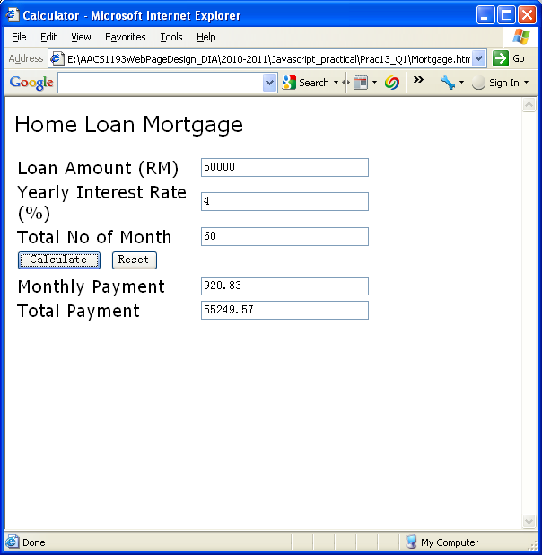

**Figure 5**

**Section B:**

Question 1

What is a server-side program? What is a client-side program?

Question 2

Provide code to attach your HTML file to a script located in the tny_functions.js file. Assume that the script file is loaded asynchronously.

Question 3

Create the following dialog boxes.

1. Alert dialog box with message “Data is invalid”.
2. Confirm dialog box with message “Submit Order?”
3. Prompt dialog box with message “Please enter your name”. Store the name in the “personName” variable

Question 4

Provide the java script command to complete the following tasks:

1. display an alert dialog box with the message “Happy New Year!”.
2. declare the variable totalMonths with an initial value of 12.
3. create a variable named expDate containing the date April 4, 2018 at 8:38:14 a.m.
4. Display current date in “DD/MM/YYYY” format into the textbox with id named bookingDate. For example, “31/5/2022”.
5. Use a while loop to validate the user input with the default password (password =123). Your function should be able to do the following tasks.

* First, a prompt dialog will pop up to user to key in the password. If the input does not match with the default password, it will pop up a prompt dialog and ask user to key in the password again.
* The prompt dialog will keep popping up until the user key in the correct password. If the user key in the correct password, an alert dialog will pop up with the message of “Password is correct”.



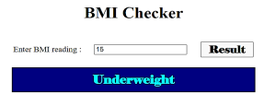

* Read the user input from the textbox with id named “bmi” and write the user input into a variable named “reading”.
* Write the Else if statement to check the “reading” variable and assign the respective message as stated in the following table to the variable named “msg”.

|  |  |
| --- | --- |
| **BMI Reading** | **Message** |
| <18.5 | Underweight |
| 18.5 to 24.9 | Normal |
| Other | Overweight |

* Display the “msg” value into the div element with id named “result” using innerHTML property